**CNV12**

query subject identity length mismatch gaps start.query end.query start.subject end.subject e.value bit.score

blaSHV-1 21f4029e-dc29-4720-984b-9fb49cffe090 93.707 874 28 24 1 861 3574 4433 0 1284

blaSHV-1 21f4029e-dc29-4720-984b-9fb49cffe090 98.077 52 1 0 1 52 6996 7047 1.84e-20 91.6

blaSHV-1 21f4029e-dc29-4720-984b-9fb49cffe090 93.915 871 26 22 3 861 46495 45640 0 1290

blaSHV-1 21f4029e-dc29-4720-984b-9fb49cffe090 94.253 870 27 20 1 861 49952 49097 0 1308

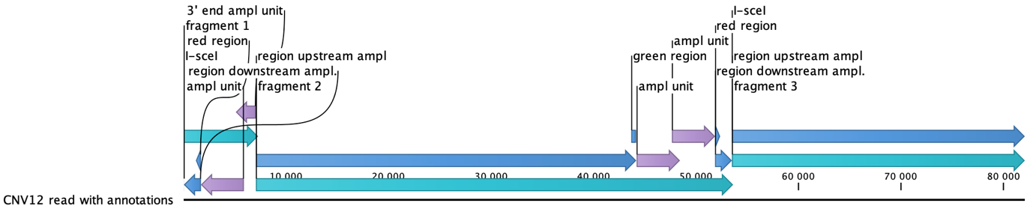

**CNV9**

query subject identity length mismatch gaps start.query end.query start.subject end.subject e.value bit.score

blaSHV-1 be55166a-1415-4f64-b234-029d76f27bb1 92.571 875 34 28 1 861 3565 4422 0 1227

blaSHV-1 be55166a-1415-4f64-b234-029d76f27bb1 89.217 881 49 39 1 859 6976 7832 0 1059

blaSHV-1 be55166a-1415-4f64-b234-029d76f27bb1 92.36 877 26 25 1 861 10401 11252 0 1210

blaSHV-1 be55166a-1415-4f64-b234-029d76f27bb1 91.657 875 34 31 1 861 36061 35212 0 1175

blaSHV-1 be55166a-1415-4f64-b234-029d76f27bb1 92.06 869 43 23 1 861 39421 38571 0 1199

